Ques1: Create a Web page to add Two numbers using servlet.

Source Code

1) HTML CODE

<!DOCTYPE html>

<html>

<body>

<form action=*"add"*>

Enter 1st number : <input type= *"text"* name = *"num1"*><br>

Enter 2nd number : <input type= *"text"* name = *"num2"*><br>

<input type = *"submit"*>

</form>

</body>

</html>

2) XML CODE

<web-app xmlns:xsi=*"http://www.w3.org/2001/XMLSchema-instance"* xmlns=*"http://xmlns.jcp.org/xml/ns/javaee"* xsi:schemaLocation=*"http://xmlns.jcp.org/xml/ns/javaee http://xmlns.jcp.org/xml/ns/javaee/web-app_4_0.xsd"* id=*"WebApp_ID"* version=*"4.0"*>

<servlet>

<servlet-name>unique_same_name_as_mapping</servlet-name>

<servlet-class>com.hitendra.AddServlet</servlet-class>

</servlet>

<servlet-mapping>

<servlet-name>unique_same_name_as_mapping</servlet-name>

<url-pattern>/add</url-pattern>

</servlet-mapping>

</web-app>

3) JAVA CODE

**package** com.hitendra;

**import** java.io.*;

**import** javax.servlet.ServletException;

**import** javax.servlet.http.*;

**public** **class** AddServlet **extends** HttpServlet {

**public** **void** service(HttpServletRequest req,HttpServletResponse res) **throws** IOException, ServletException {

**int** a = Integer.*parseInt*(req.getParameter("num1"));

**int** b = Integer.*parseInt*(req.getParameter("num2"));

**int** k = a+b;

PrintWriter out = res.getWriter();

out.println(k);

}

}

Output

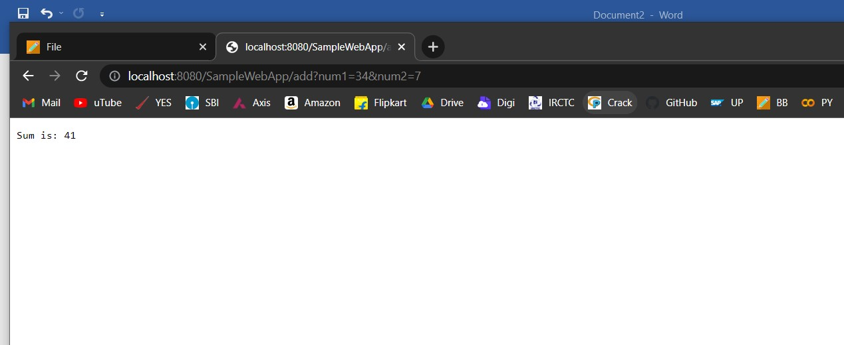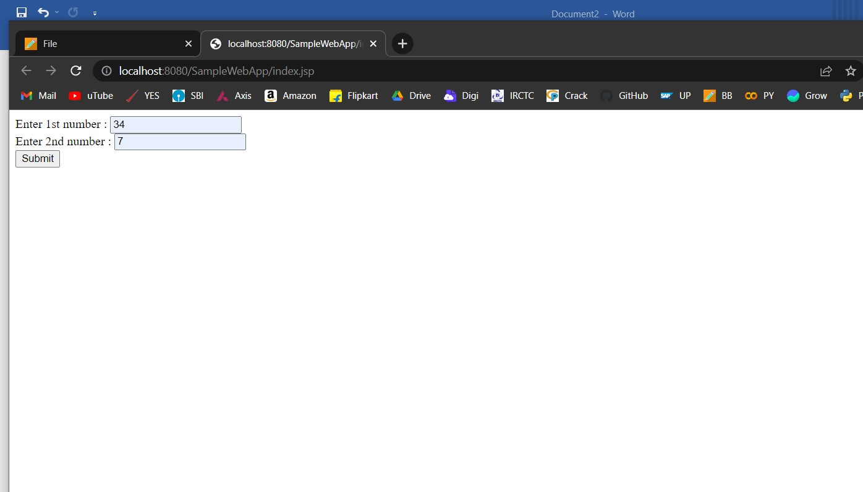

Ques2: Create a Web page to add Two numbers using JSP.

Source Code

1. HTML CODE

<!DOCTYPE html>

<html>

<body>

<form action=*"sum.jsp"*>

Enter 1st number : <input type= *"text"* name = *"num1"*><br>

Enter 2nd number : <input type= *"text"* name = *"num2"*><br>

<input type = *"submit"*>

</form>

</body>

</html>

1. JSP CODE

<%@ page language=*"java"* contentType=*"text/html; charset=ISO-8859-1"*

pageEncoding=*"ISO-8859-1"*%>

<!DOCTYPE html>

<html>

<head>

<meta charset=*"ISO-8859-1"*>

<title>Title Of This Page</title>

</head>

<body>

<%

**int** a = Integer.parseInt(request.getParameter("num1"));

**int** b = Integer.parseInt(request.getParameter("num2"));

**int** k = a+b;

out.println("Sum is using JSP: "+k);

%>

</body>

</html>

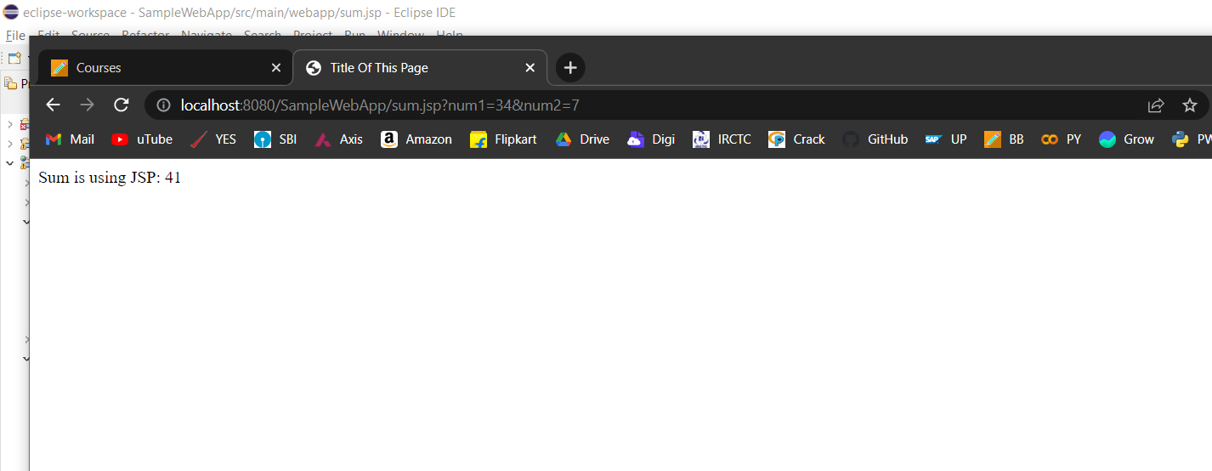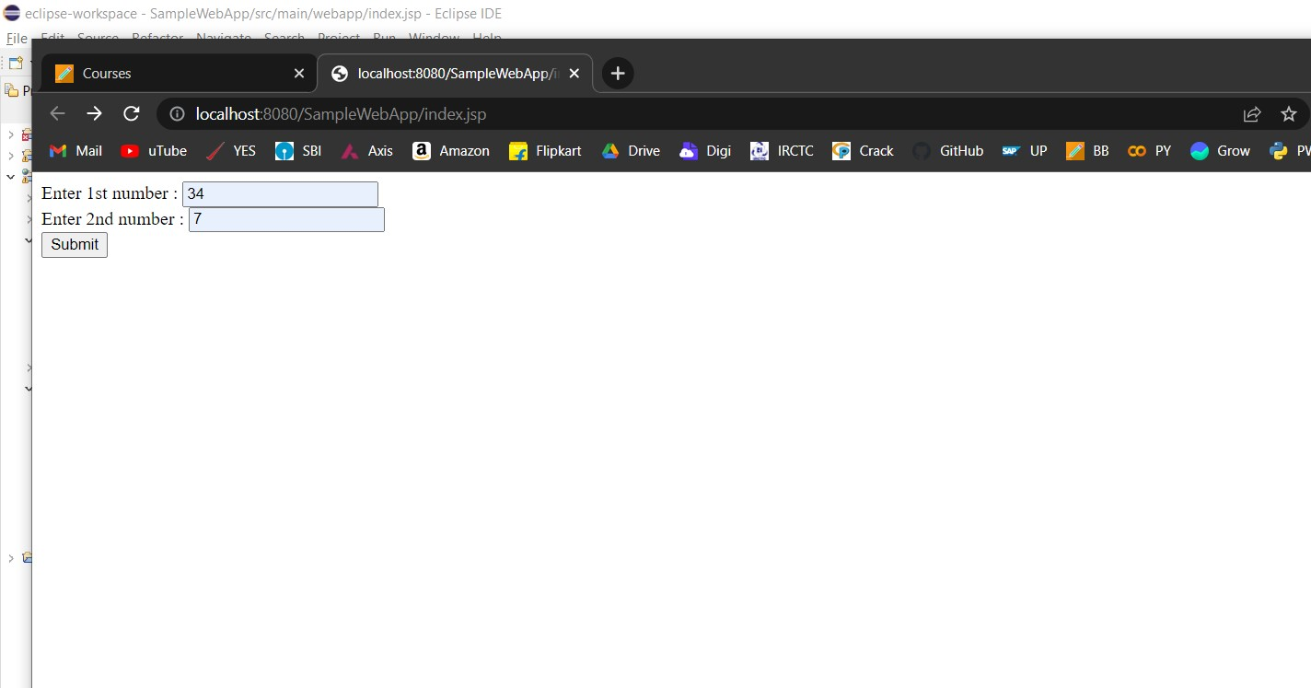Output